Task 1

Start with a Group Room. While in the rooms be sure to have the Javascript Console and the Request Inspector Open, and that you are capturing screen shots of the output from both the JS Console and the Request Inspector.

1> Index Page

Localhost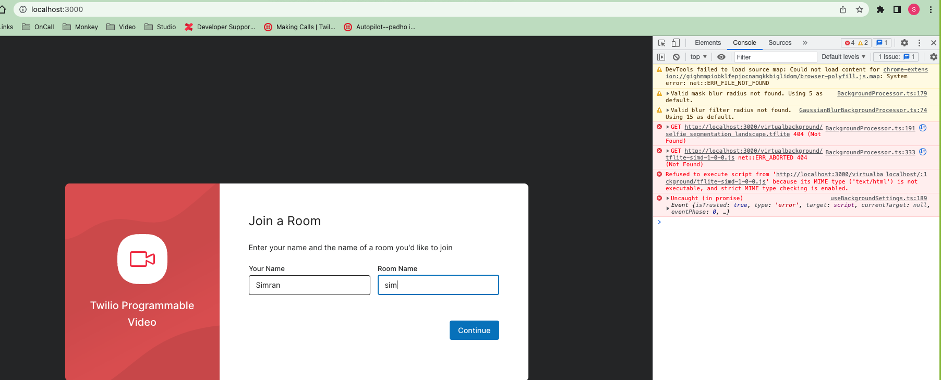

Function:

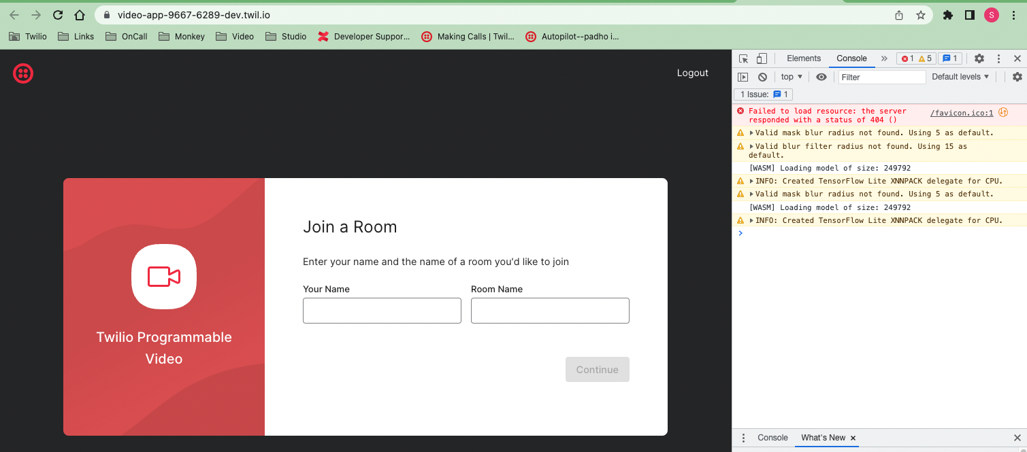

2> Room Sim

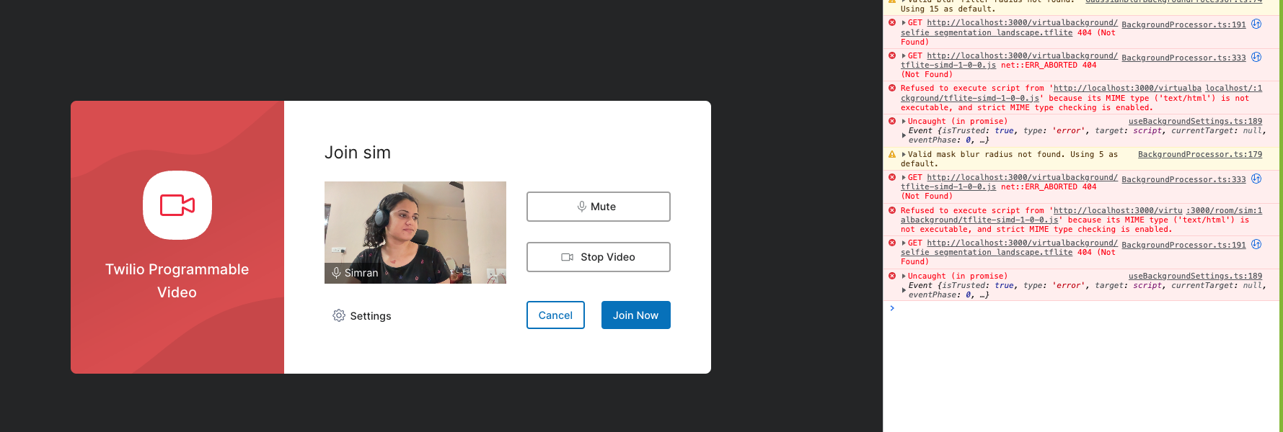

3> Room Joined

RoomSid : RM9c43b8588855b86df296de644900a08a

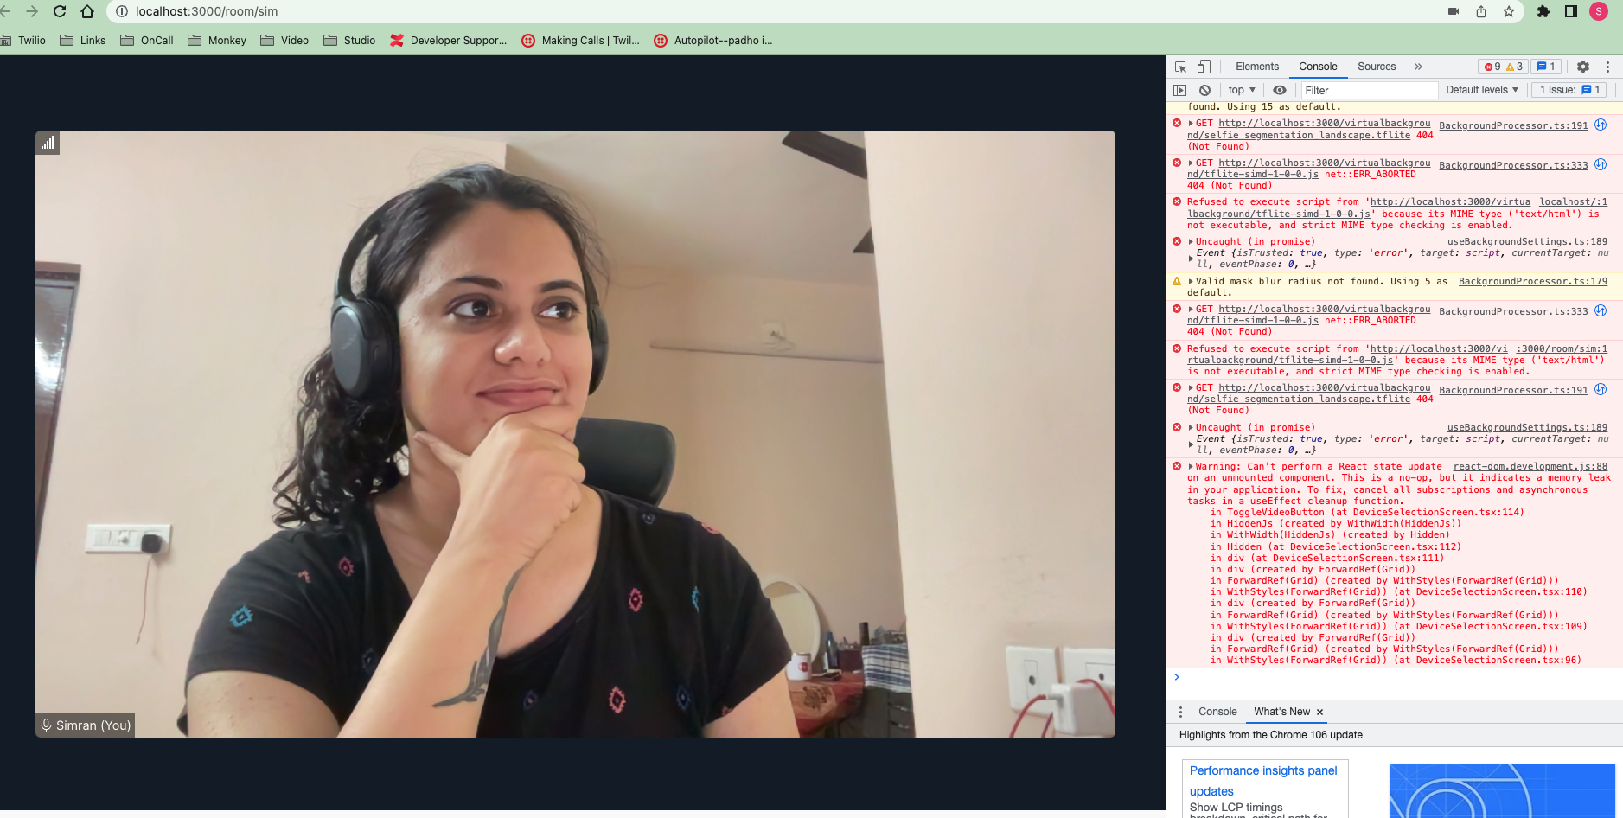

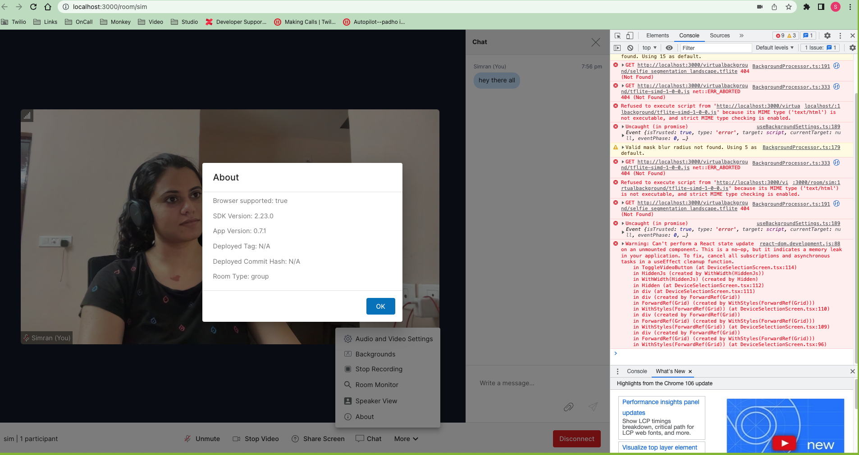

4> Req Inspector

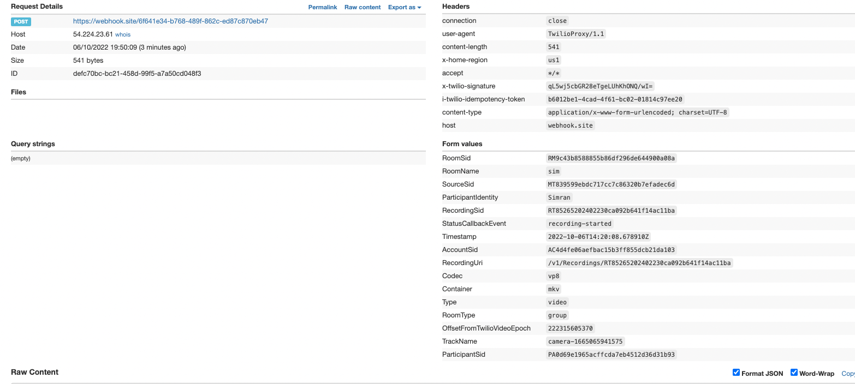

5> Options avail in Room :

1. More

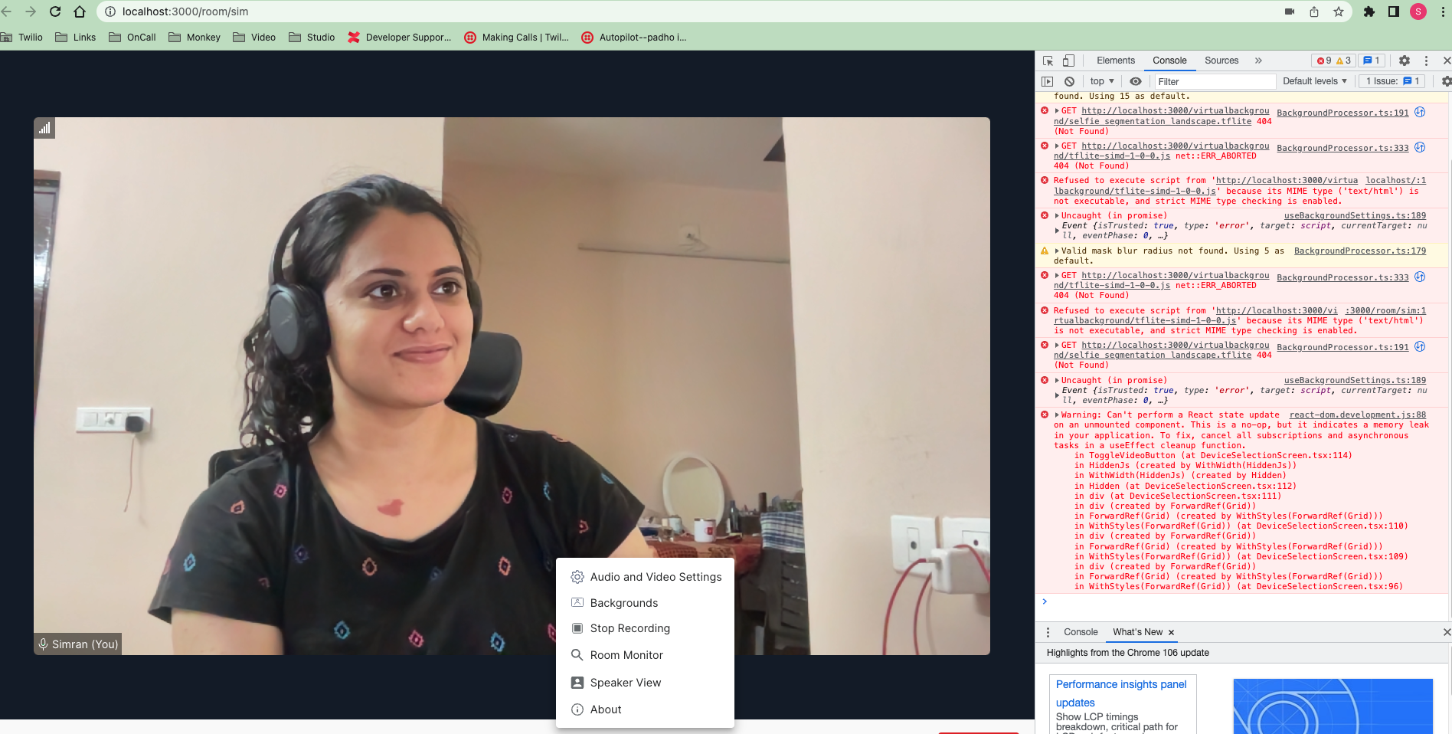

1. Chat :

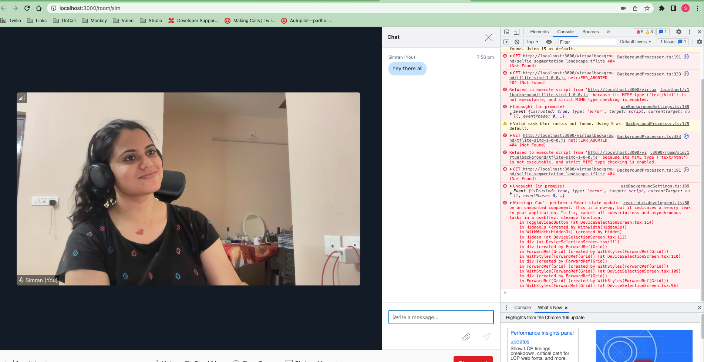

1. Screen Share :

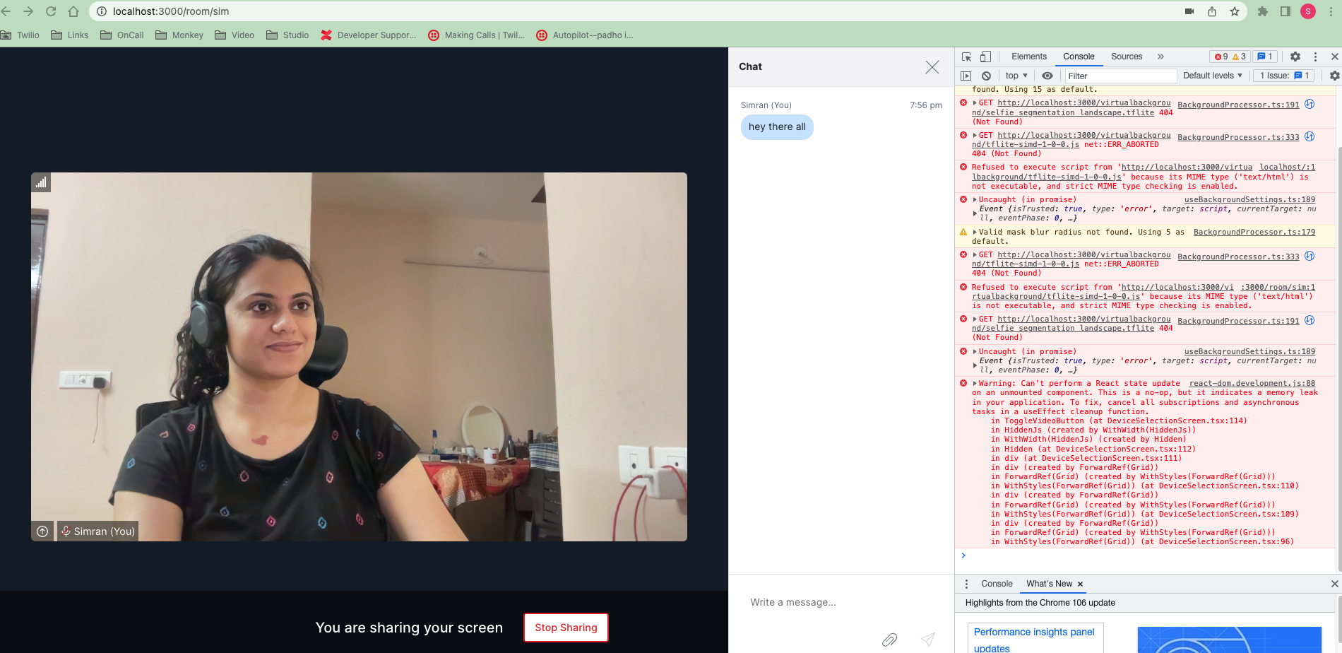

1. Room Monitor :

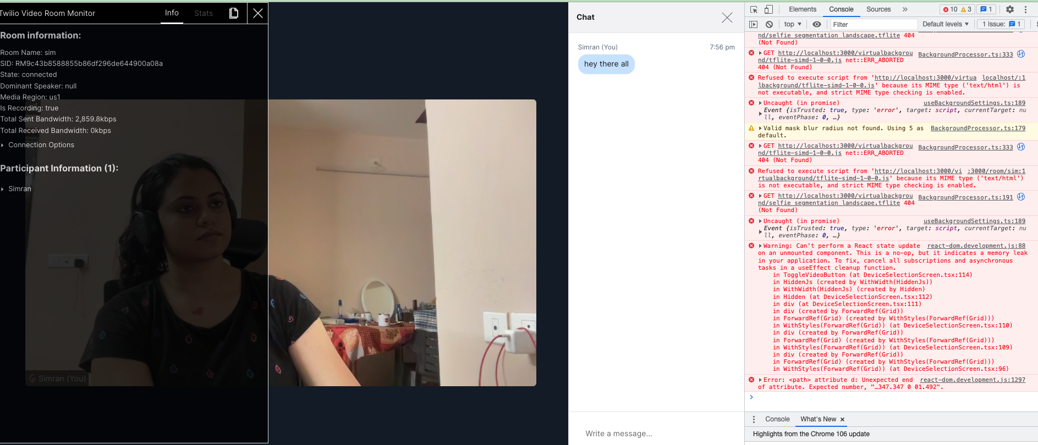

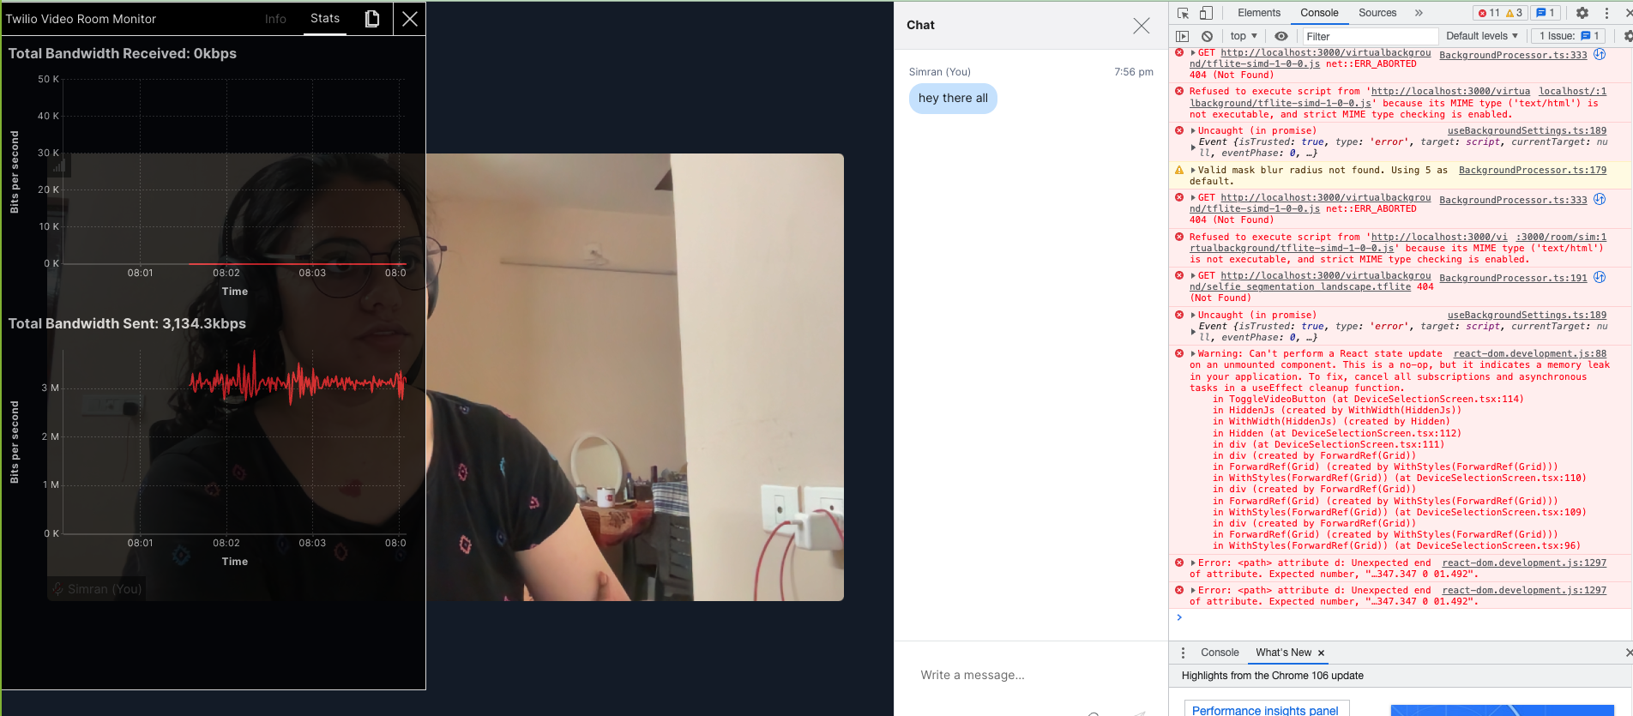

5> Virtual Background :

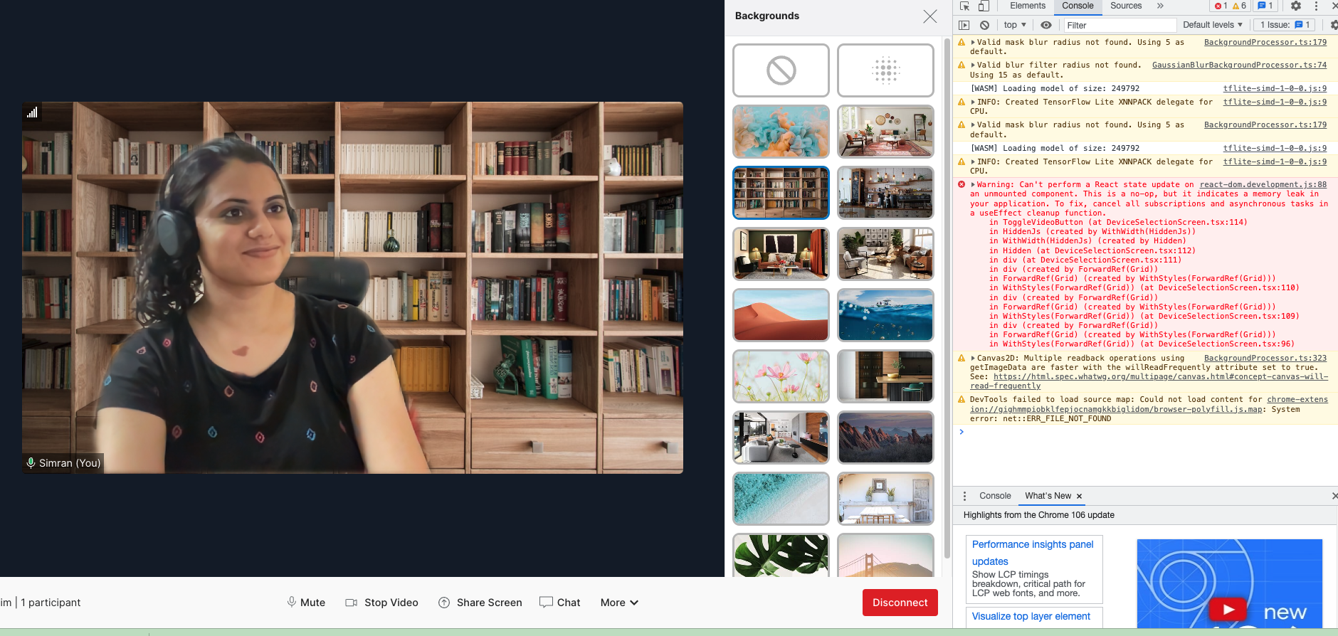

+++++++++++++++++++++++++++++++++++

Task 2

1>

Share the Demo App URL and passcode with a friend and create a Group room.

| RoomSid : | RM5c34ab92663e3ddfdc0e9ecb93b5276f |
| --- | --- |

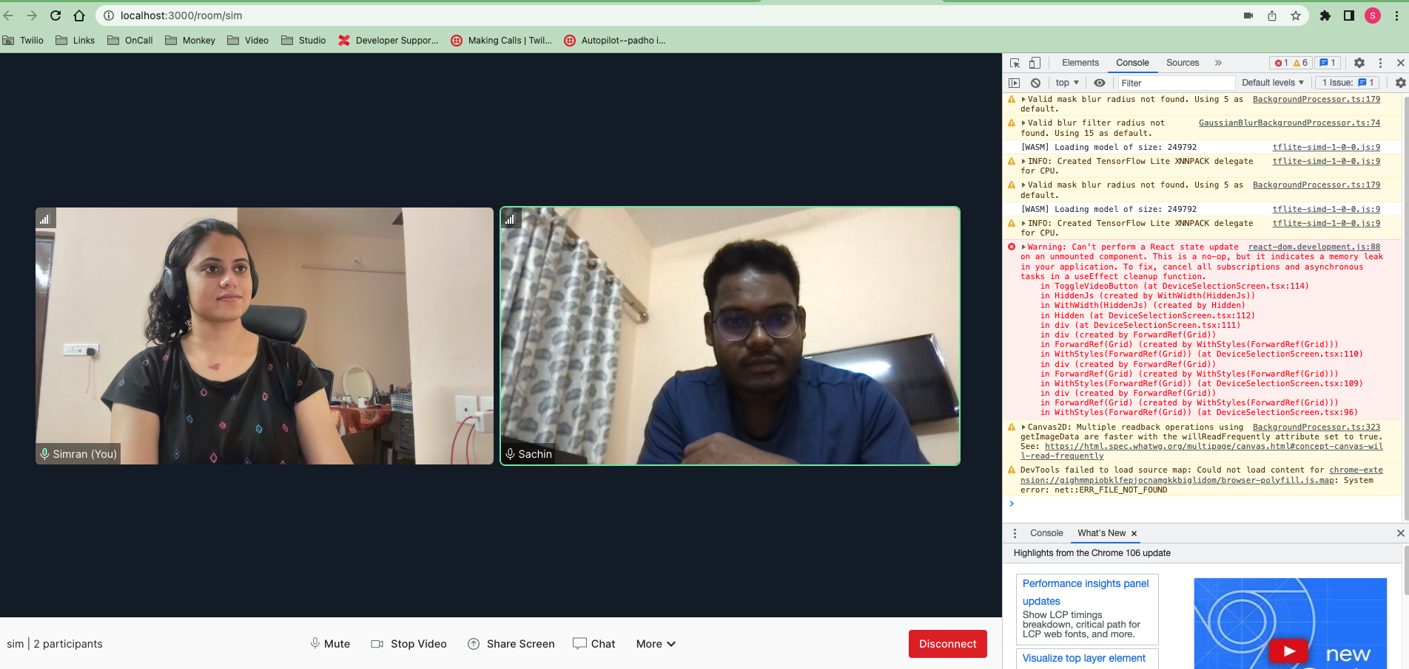

2> Both Participants on Mute :

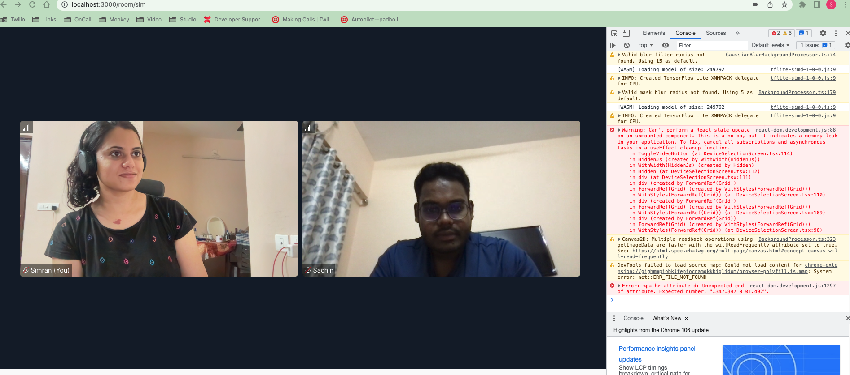

3> Both Participants on Video Off :

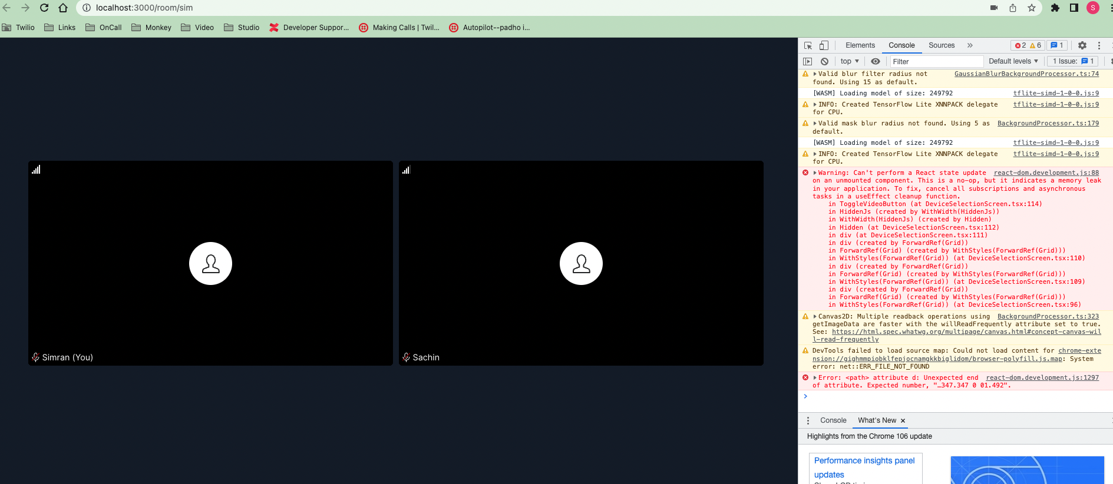

4> Participants sharing Chat :

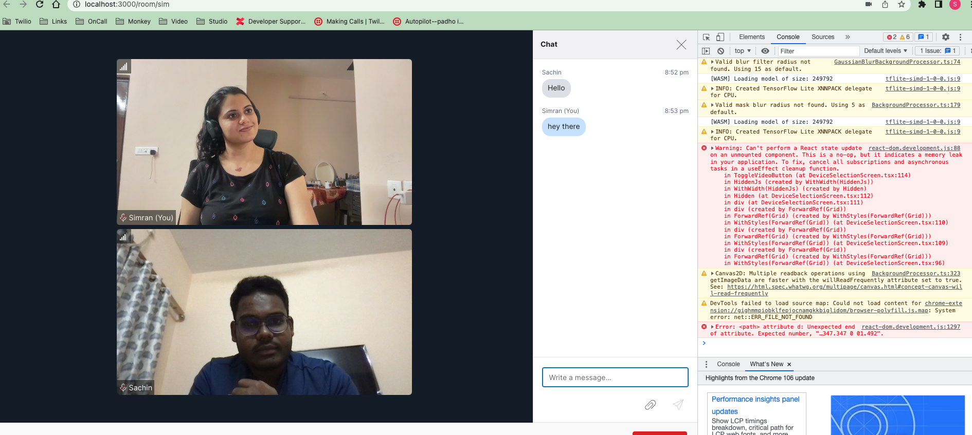

**5>** Participants with Recording ON/OFF :

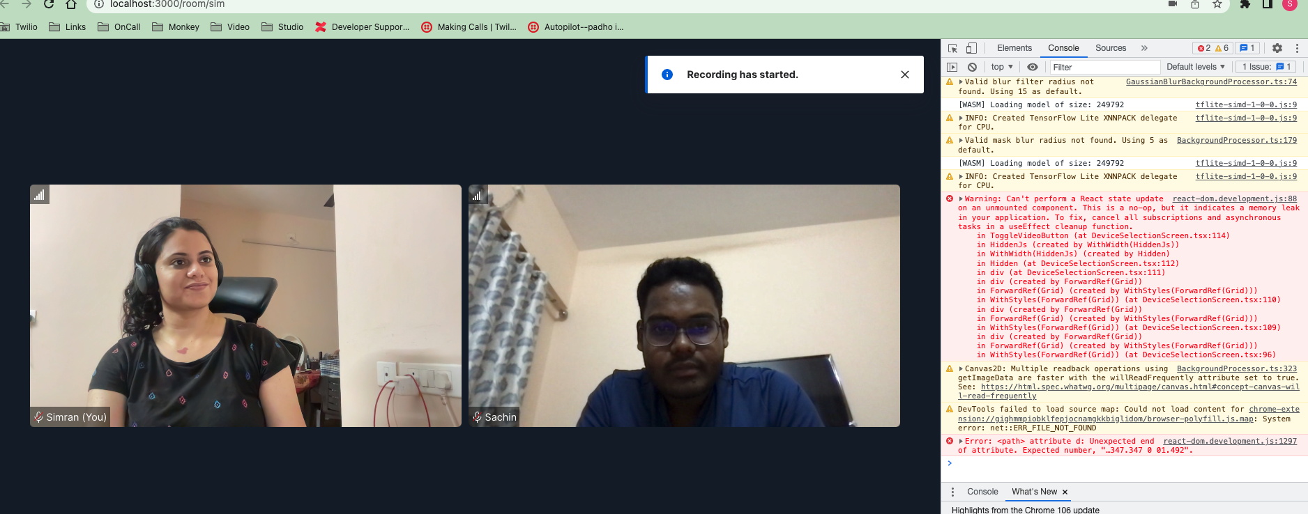

6> Participants with Virtual Background :

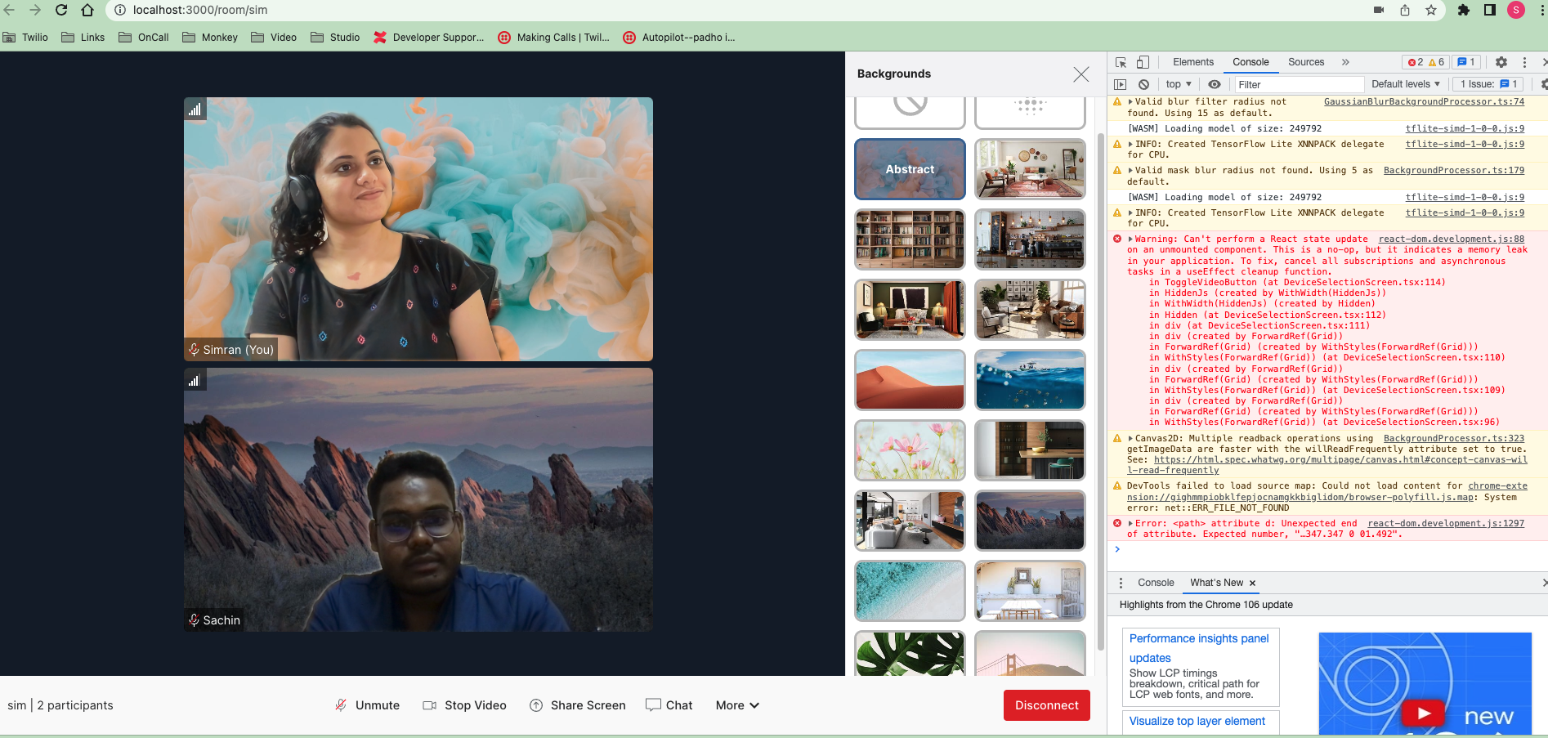

7> When Participant 2 dropped his network :

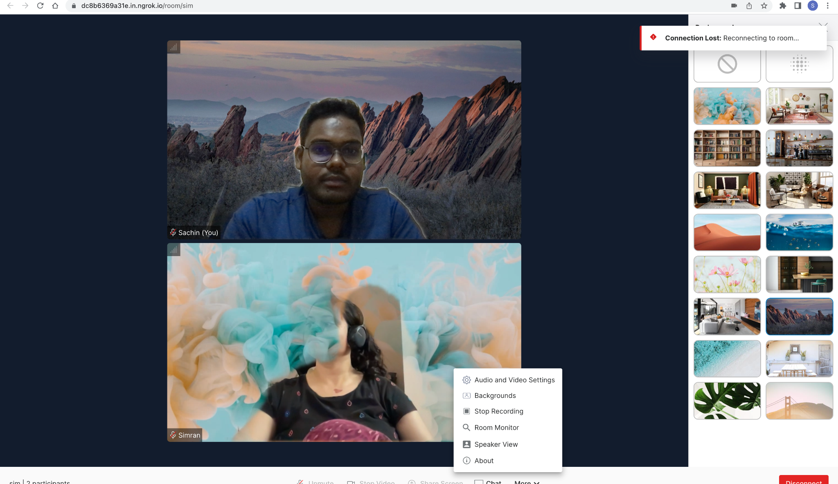

8> Audio Input dropdowns

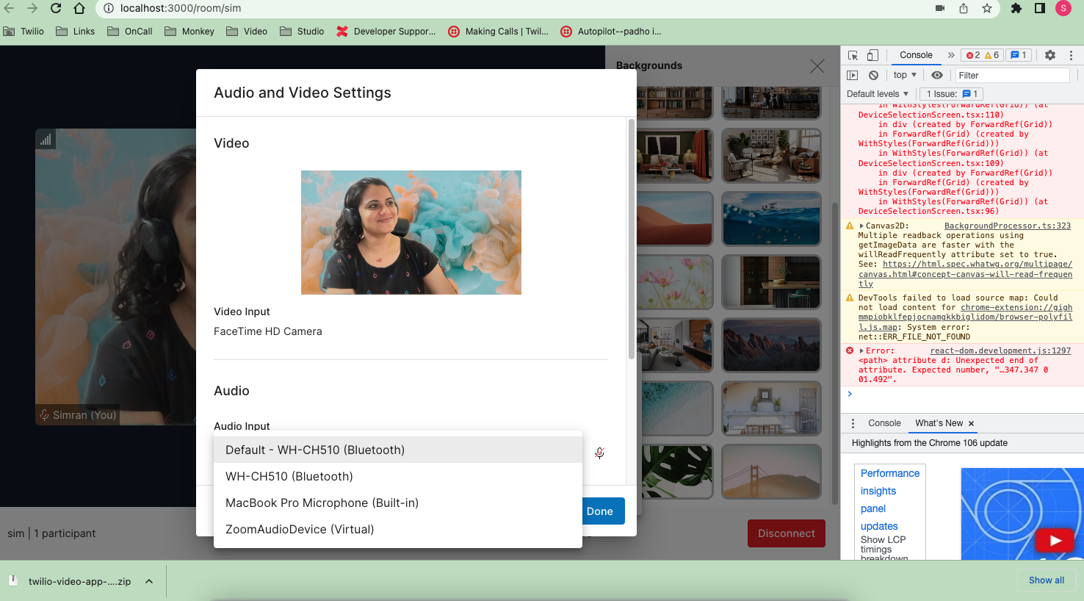

9> Adding [krisp.ai](http://krisp.ai/) to the audio input selector.

<https://www.npmjs.com/package/@twilio/krisp-audio-plugin>

<https://github.com/twilio/twilio-video.js/blob/master/CHANGELOG.md#2230-july-28-2022>

twilio-video-app-react/src/components/VideoProvider/useLocalTracks/useLocalTracks.ts

**line no 18**

// return Video.createLocalAudioTrack(options).then(newTrack => {

return Video.createLocalAudioTrack({

noiseCancellationOptions: {

sdkAssetsPath: '../../../../server/dist', // node_modules/@twilio/krisp-audio-plugin/dist/ is in server directory

vendor: 'krisp'

}

}).then(newTrack => {

++++++++++++++++++++++++++++++++++++++++

Task 3

Create at minimum two Group Rooms with two or more participants to generate logs and recordings.

**Room 1**

Room Name: Sim

SID: RM5c34ab92663e3ddfdc0e9ecb93b5276f

**Room 2**

Room Name: Ann

SID: RM792acfbd09548a441493f4994c8d7dfc

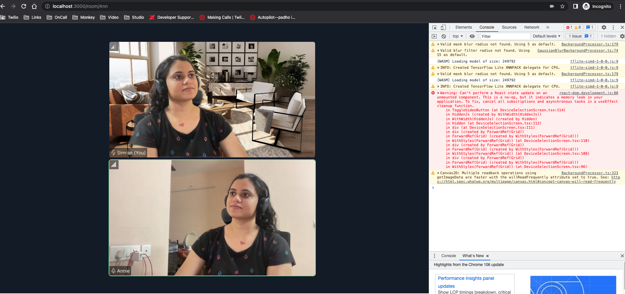

2> Logs from Programmable video Bot :

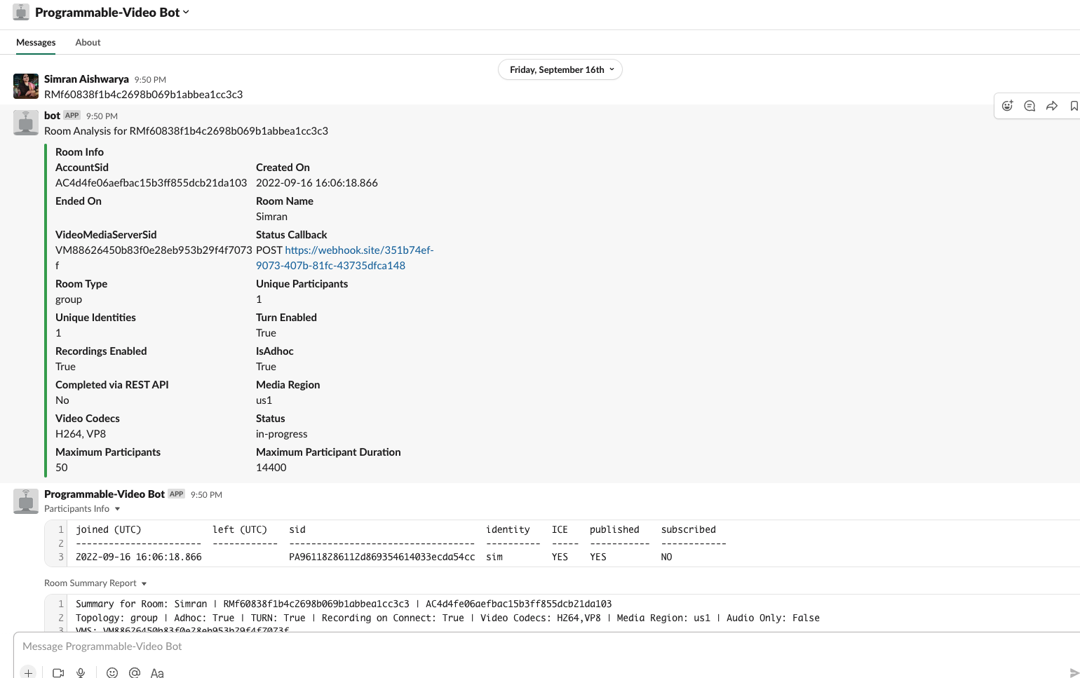

>>

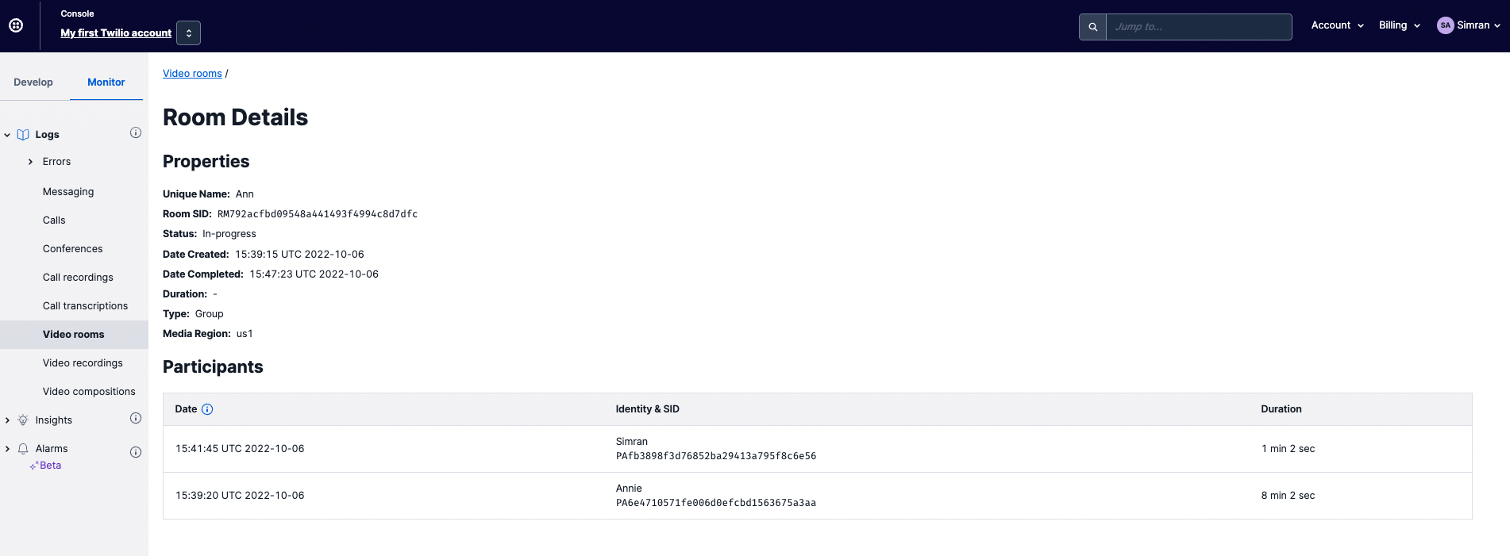

Recording logs :

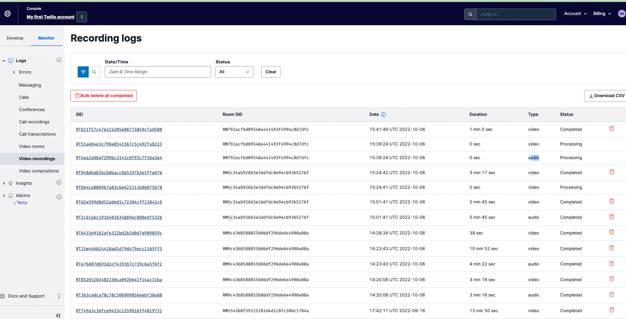

+++++++++++++++++++++++++++++++++++++++++++++++++

Task 4

Add one PSTN participant to a room following [Adding Programmable Voice participants to Video Rooms](https://www.twilio.com/docs/video/adding-programmable-voice-participants-video-rooms)

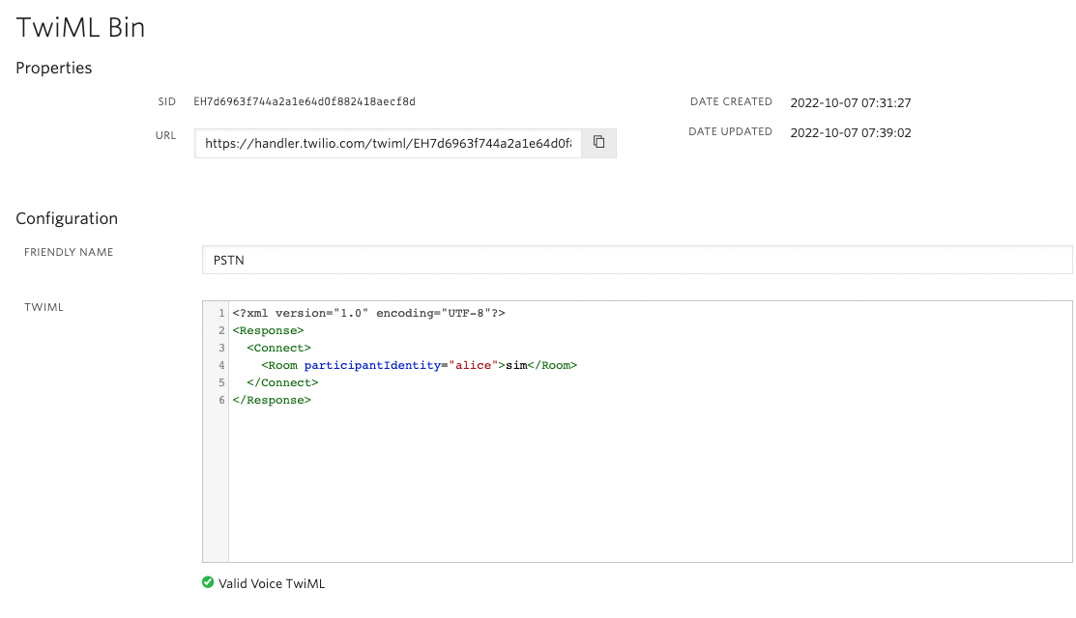

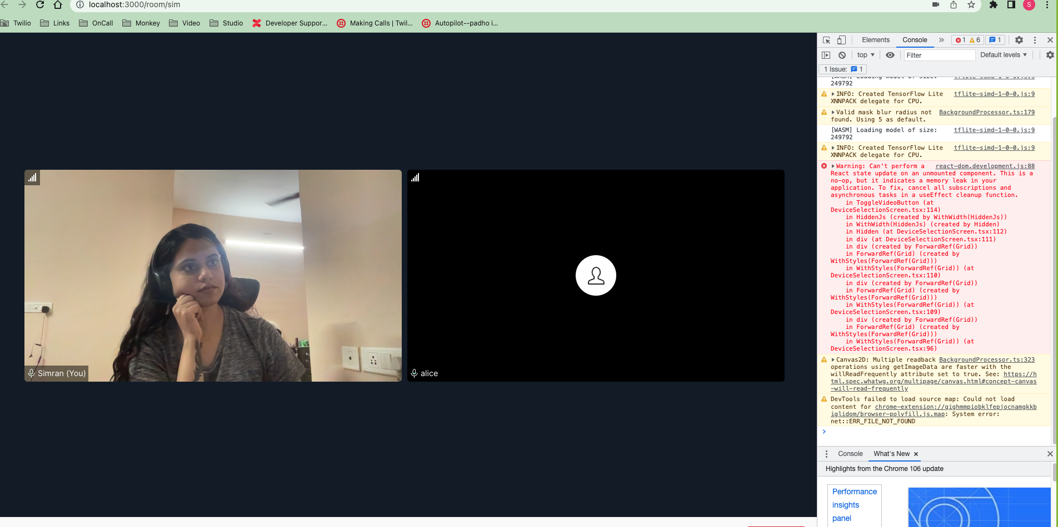

+++++++++++++++++++++++++++++++++++++++++++++++

Task 5

Create one Peer-to-Peer room.

Room Name: sim

SID: RMb8029e34bd793091c86ccbb8b04411df

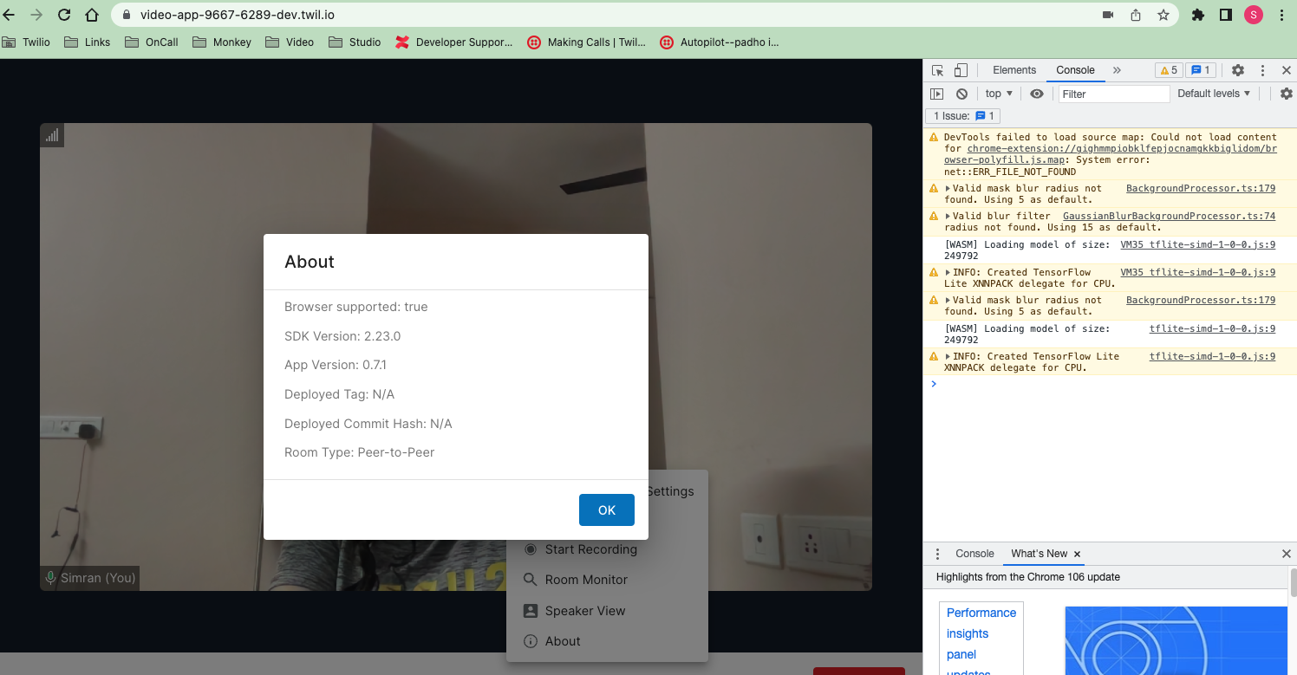

+++++++++++++++++++++++++++++++++++++++++++

Task 6

Recording Logs :

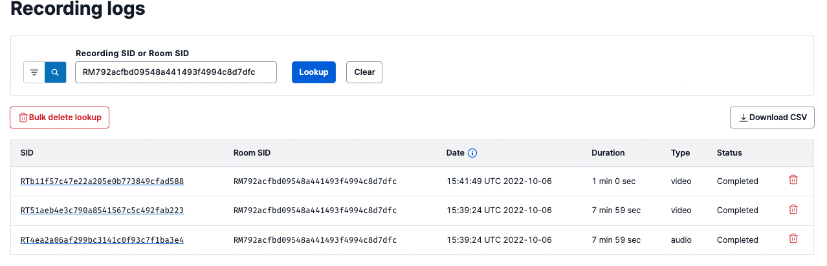

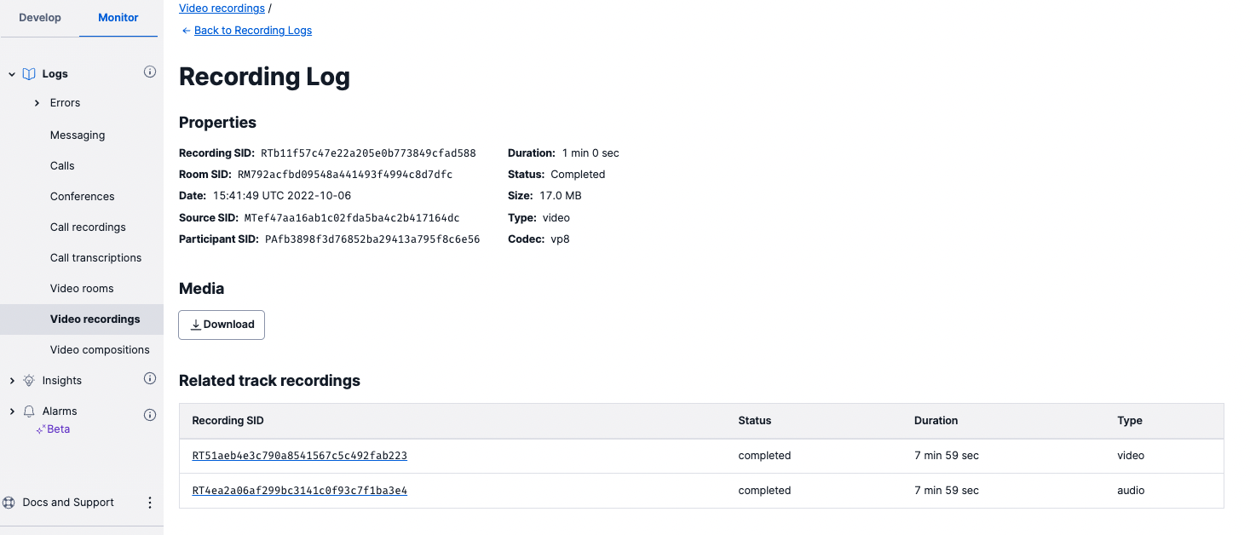

Usage Logs :

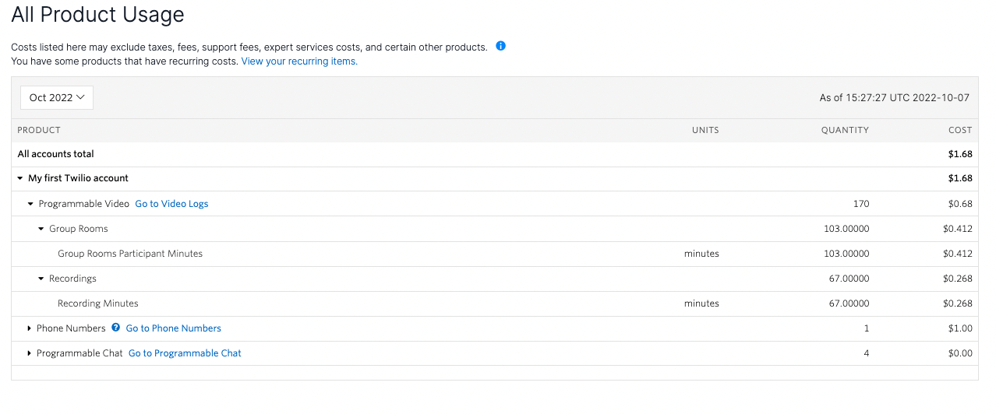

Room Logs:

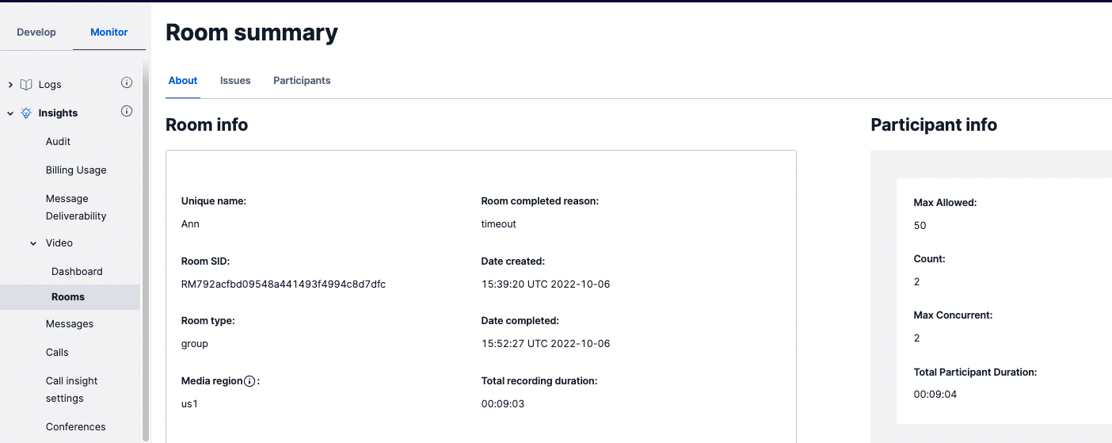

Monkey logs:

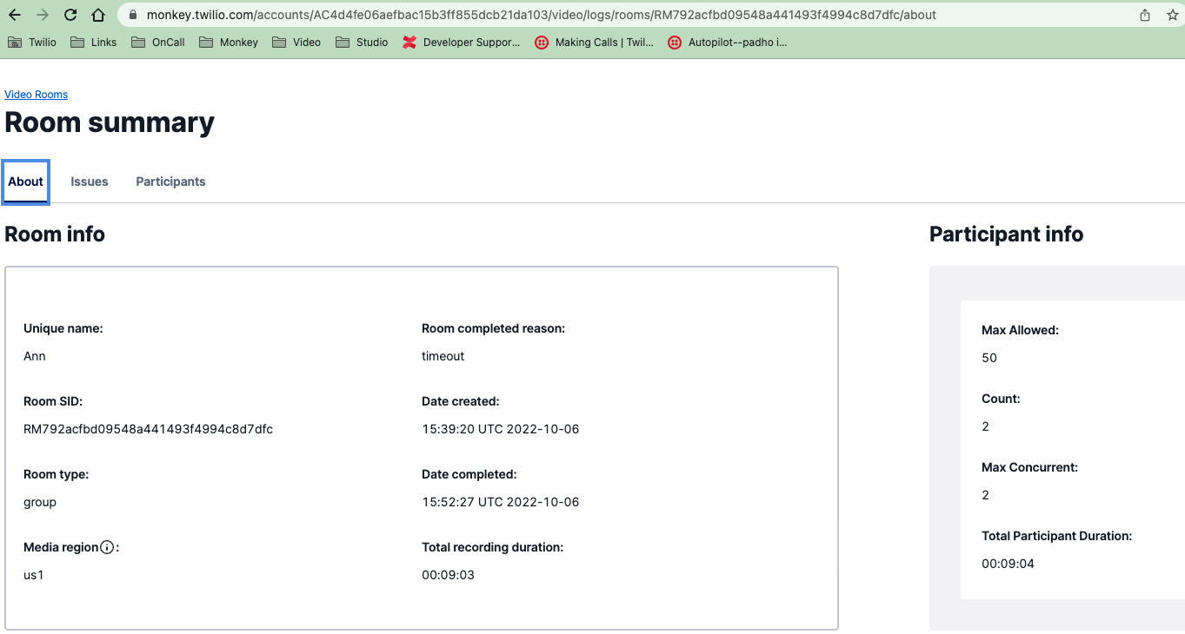

++++++++++++++++++++++++++++++++++++++++++++

Review what is captured in Monkey Video Log Analyzer [https://monkey.twilio.com/accounts/{Your](https://monkey.twilio.com/accounts/%7BYour) Account SID}/video/logs/rooms

> Logs/details captured in Monkey is similar to : <https://www.twilio.com/console/video/logs/rooms>

All details related to room aswell as participants are given.

++++++++++++++++++++++++++++++++++++++++++++

Explain the differences in output in a document in GH between Group rooms and P2P rooms.

Differences in output between Group rooms and P2P rooms:

1. Media region is only available for group room types.

2. Maximum Participant allowed for group room type is 50 whereas for P2P room it can support up to 10 audio-only participants, but max 3 participants recommended when video is published.

3. Group Rooms can support up to 35 PSTN participants.

4. Recording is supported by Group room whereas it is not supported by P2P room.

5. Dominant Speaker Detection is supported by Group room whereas it is not supported by P2P room.

6. E2E encryption is not supported by Group room whereas it is supported by P2P room.